Title of the presentation | 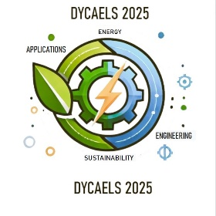
A. Author¹, B. Author², C. Author³

¹Affiliation and email
²Affiliation and email
³Affiliation and email

Abstract:
(The abstract should contain about 20 lines)

Structural systems are typically designed with multiple components, Structural systems are typically designed with multiple components, Structural systems are typically designed with multiple components, Structural systems are typically designed with multiple components, Structural systems are typically designed with multiple components, Structural systems are typically designed with multiple components, Structural systems are typically designed with multiple components, Structural systems are typically designed with multiple components, Structural systems are typically designed with multiple components, Structural systems are typically designed with multiple components, Structural systems are typically designed with multiple components, Structural systems are typically designed with multiple components, Structural systems are typically designed with multiple components, Structural systems are typically designed with multiple components, Structural systems are typically designed with multiple components, Structural systems are typically designed with multiple components, Structural systems are typically designed with multiple components, Structural systems are typically designed with multiple components Structural systems are typically designed with multiple components, Structural systems are typically designed with multiple components, Structural systems are typically designed with multiple components, Structural systems are typically designed with multiple components, Structural systems are typically designed with multiple components, Structural systems are typically designed with multiple components, Structural systems are typically designed with multiple components, Structural systems are typically designed with multiple components, Structural systems are typically designed with multiple components, Structural systems are typically designed with multiple components.

References
(Provide 2 or 3 references if necessary)

1. A. Author, B. Author, C. Author, Journal 55, 11-22, 2017.
2. A. Author, B. Author, C. Author, Book, Edition, 2017.
3. A. Author, B. Author, C. Author, Conference name, period of the conference, venue, 2017.

